Design Document: Avenu Mail Notification System
1. Introduction Jonathan Gu
1.1 Purpose
The Avenu Mail Notification System is a web-based application designed to streamline the mail management process for Avenu, a coworking space for startups. The system aims to replace the current inefficient manual process of handling mail inquiries with an automated, transparent, and user-friendly digital solution.
1.2 Problem Statement
Avenu receives hundreds of letters and packages weekly. Currently, Avenu employees spend valuable time each day fielding manual inquiries from members regarding their mail status. This creates a bottleneck for staff and frustration for members who lack visibility into their mailbox contents.
1.3 Scope
The application will serve two primary user groups:
- Avenu Staff (Admins): Who need an efficient interface to log incoming mail.
- Coworking Members: Who need timely updates on their mail status without contacting staff.
The scope of the MVP includes a mobile-optimized admin dashboard for logging mail, a member dashboard for viewing history, and an automated weekly email summary system.

2. Goals and Objectives Jonathan Gu
2.1 High-Level Goals
- Make the Client Happy: Deliver a solution that saves time and is maintainable by the client after the semester ends.
- Reduce Administrative Load: Minimize the time staff spends answering "do I have mail?" questions.
- Improve Member Experience: Provide members with reliable notifications and a clear history of their mail.
2.2 Success Metrics
- Key Result 1: Delivery of an easy-to-use admin dashboard for updating user information.
- Key Result 2: Successful implementation of reliable notifications for letters and packages.
- Key Result 3: Reduction in manual email/in-person inquiries regarding mail volume (qualitative metric).

3. User Stories and Requirements
3.1 Admin (Staff) Requirements
- Mail Logging (MVP): As an admin, I want to update the number of mail items (letters/packages) a member received that day so I can provide accurate information.
- Dashboard Trigger (MVP): As an admin, I want to trigger notifications from a dashboard to avoid manual emailing.
- Mobile Workflow: The admin dashboard must be mobile-first to accommodate staff logging mail while standing in the mailroom sorting items.
- Search Functionality: Admins must be able to search by Company Name or Member Name to locate the correct mailbox.
3.2 Member (Startup) Requirements
- Weekly Summary (MVP): As a member, I want a weekly email summary (Monday) of received mail so I don't have to ask staff.
- Clarity: The notification must distinguish between letters and packages and provide counts.
- History: As a member, I want a dashboard to view my past mail delivery history.
- Notification Preferences: As a member, I want to toggle notifications on/off.
3.3 "Nice to Have" (Future Iterations)
- OCR Scanning: Admin uploads a photo of mail, and the system parses sender/receiver info automatically.
- Urgent Requests: Members can submit a request for an expected urgent item to get immediate notification upon arrival.
- SMS Notifications: Members can choose text messages over email.

4. System Architecture Jonathan Gu
4.1 Tech Stack
- Frontend: React (Web & Mobile Responsive). Utilizing Tailwind CSS for rapid, mobile-first UI development.
- Backend: Python (Flask) - A lightweight micro-framework ideal for rapid prototyping and easy integration with MongoDB.
- Database: MongoDB Atlas (NoSQL). Chosen for its flexible schema, allowing the mail_records collection to evolve as we refine the data model.
- Containerization: Docker. Dockerfiles for both frontend and backend to ensure parity between local development and production environments.
- Testing: Behave (Behavior Driven Development) for testing scripts.
4.2 Architecture Diagram
The system follows a standard client-server architecture. The frontend communicates with the backend via RESTful APIs. The backend handles logic, database operations, and triggers the email service.

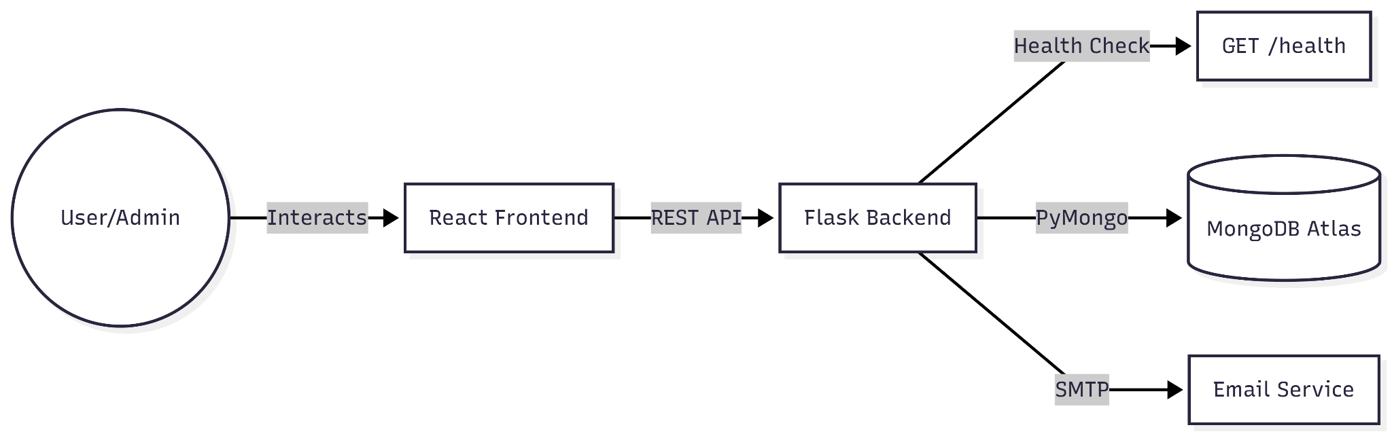

User/Admin Interface: This is where staff log mail and members view their history via a mobile-optimized React application.
Rest API Bridge: React communicates with the Flask backend through a RESTful API, which acts as the structured communication channel for the system.
Flask Logic & Health: The Python backend handles business logic and includes a /health endpoint to verify the service is running independently.
MongoDB Atlas Storage: Data is persisted in the cloud using MongoDB Atlas, where the mail_records collection stores all delivery information.
Automated Services: The backend triggers the Email Service via SMTP to send weekly mail summaries and notifications to members.

5. Data Model

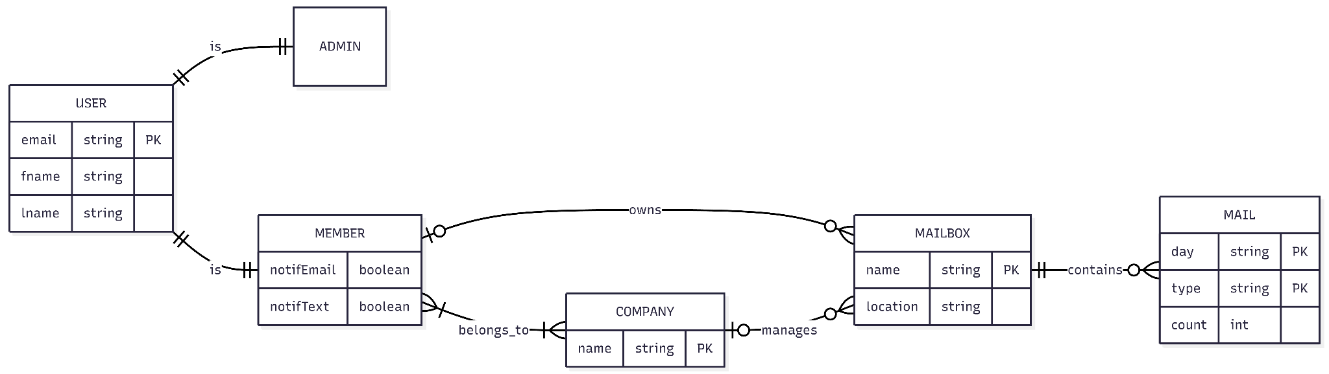

Core Entities
User
The User entity represents all individuals interacting with the system and serves as a parent entity for specialized user roles. The data values will be obtained from the Optix API.
Attributes
- email (PK) – Unique identifier for each user.
- fname – User’s first name.
- lname – User’s last name.
The User entity is implemented using specialization, allowing different types of users to inherit shared identity attributes.

Admin
The Admin entity is a specialization of User. It represents users with administrative permissions within the system.
Admins inherit all attributes from User and are responsible for managing mail notification operations.

Member
The Member entity is another specialization of User and represents individuals who receive mail and interact with companies and mailboxes.
Attributes
- notifEmail – Indicates whether the member receives email notifications.
- notifText – Indicates whether the member receives SMS notifications.
Members are associated with companies and may own personal mailboxes used for receiving mail.

Company
The Company entity represents organizations that members can belong to and that may manage mailboxes.
Attributes
- name (PK) – Unique identifier for each company.
Companies can be linked to multiple members and may manage multiple mailboxes (eg, one for each location they work out of).

Mailbox
The Mailbox entity represents physical delivery locations where mail is received.
Attributes
- name (PK) – Unique mailbox identifier.
- location – Physical address/location of the mailbox.
Mailboxes serve as the central delivery destination for mail and may be owned by members or managed by companies.

Mail
The Mail entity stores aggregated records of mail delivered to a mailbox.
Attributes
- day (PK) – Date mail was delivered.
- type (PK) – Category of mail (e.g., package, letter).
- count – Number of mail items delivered.
Mail is modeled as a dependent entity that exists only in relation to a mailbox. Each mail record represents summarized daily mail counts by type.

Relationships
User Specialization
- A User may be specialized into either an Admin or a Member.
- Both Admin and Member inherit the primary key from User.
This structure reduces redundancy and enforces consistent identity management across user roles.

Member–Company Association
Members must belong to at least one company, while companies may have multiple members.
This many-to-many relationship supports scenarios where:
- Members participate in multiple organizations.
- Companies manage multiple users within the system.

Member Ownership of Mailboxes
Members may own zero or more mailboxes. A mailbox may optionally be associated with a member owner.
This relationship supports individual mail delivery locations assigned to specific users.

Company Management of Mailboxes
Companies may manage zero or more mailboxes. A mailbox may optionally be associated with a managing company.

Mailbox–Mail Relationship
Mailboxes contain zero or more mail records. Mail entries cannot exist independently and must be associated with a mailbox.
Mail records are uniquely identified using:
- Mailbox
- Delivery day
- Mail type
This ensures accurate historical tracking of mail delivery volume.

Design Considerations
Normalization
The model separates users, organizations, delivery locations, and mail tracking into distinct entities to minimize redundancy and maintain data integrity.
Extensibility
The inheritance structure allows additional user roles to be added without modifying core identity data. Similarly, mailbox ownership and management relationships allow future expansion to support additional delivery scenarios.
Data Integrity
Composite identification of Mail ensures that mail counts remain unique per mailbox, date, and mail type. Dependency relationships enforce that mail records cannot exist without valid delivery locations.
Real-World Alignment
The design mirrors real-world mail workflows where:
- Users belong to organizations.
- Organizations and individuals manage delivery points.
- Mail is delivered to locations rather than directly to individuals.

6. User Interface & Workflow
6.1 Admin Workflow (Mobile)
- Daily Record Overview
  - Admin logs into the Admin Dashboard.
  - The dashboard defaults to the current date but allows the admin to change the date using the dropdown selector.
  - The dashboard displays a list of mail records for that date, showing each mailbox along with counts of letters and packages received for it.
- Add Mail Record
  - Admin selects Add Record from the dashboard.
  - Admin can search for a mailbox using the search bar.
  - Search results appear based on the keyword, as follows:
    - all companies with a mailbox that text-match directly
    - companies with a mailbox with any members that text-match
    - members with a personal mailbox that text-match directly
  - Admin chooses the appropriate mailbox.
  - The system navigates to the record entry interface for that mailbox.
  - The date field auto-fills with the current date but can be edited if needed.
  - Admin enters the number of letters and packages received.
  - Admin saves the record.
  - Saved records update the daily dashboard summary.
  - Updated mail counts become available for member weekly summaries and notifications.
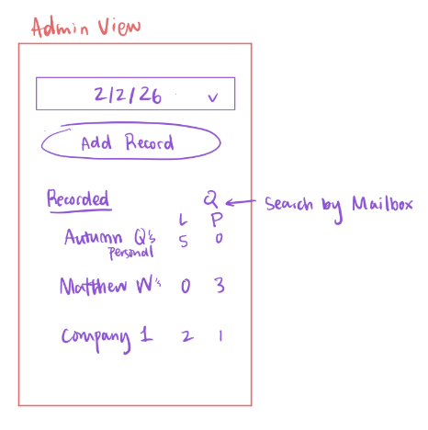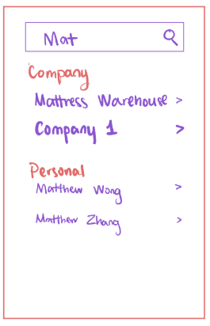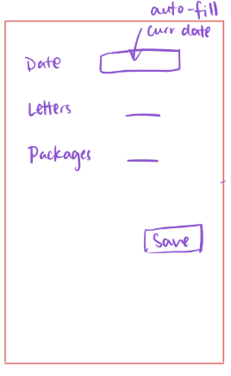
6.2 Member Workflow (Mobile)
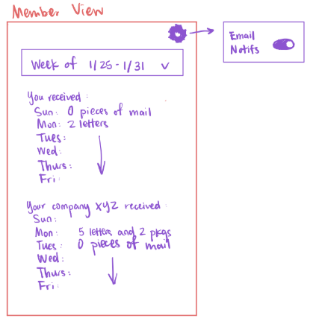
- Dashboard Overview
  - Member accesses the Member View dashboard.
  - The dashboard defaults to showing the current week.
  - Member can change the selected week using the dropdown selector.
- Mail Summary
  - The dashboard displays a separate section for each mailbox a member’s associated with (eg personal, company).
  - For each section, a daily breakdown of mail received for that mailbox is shown, organized by day of the week.
  - Each day shows the number and type of items received (ex. letters, packages).
- Notification Settings
  - Member can access Email Notification settings via the settings icon.
  - Member can enable or disable email notifications.

7. Risks and Mitigation Strategy Jonathan Gu
Risk Category | Specific Risk | Impact | Likelihood | Mitigation Strategy
Technical | Optix integration problems | Medium | Low | Test quickly; if it fails, pivot to manual CSV import immediately.
Security | Data storage security (User data) | High | Medium | Research encryption options; minimize PII stored; strict role-based access control.
Client | Disagreement amongst clients | High | Very High | Limit options presented to client; set up meetings to clarify expectations early.
Maintenance | Unmaintainable code | High | Low | Choose a standard tech stack; conduct strict code reviews; create comprehensive documentation.

8. Implementation Timeline
(see kanban board for elaboration on each issue)
Sprint 1
- Decide on a specific tech stack (Django vs React + Flask).
- Set up the GitHub repo and Kanban board.
- Create README and architectural diagrams.
Sprint 2 – Platform + identity + core data model
Goal: System boots, identities are trusted, and mail data can exist.
- Set up project infrastructure
- Staff authentication and role model
- Support manual admin mail intake
- Add a dashboard for daily mail intake recording
Sprint 3 – Admin workflow + member visibility
Goal: Staff can operate the system effectively, and members start seeing value.
- Admin mail intake history view
- Member authentication via Optix Canvas
- Member mail history dashboard
Sprint 4 – Notification foundation
Goal: Towards allowing members to be notified by the system automatically.
- Build notification engine
- Notification preferences management
Sprint 5 – Weekly summaries live
Goal: Deliver the core promise without manual intervention.
- Weekly mail summary notification

9. Future Roadmap
Support mail requests and alerts
- Member mail request submission
- Immediate alert on request match
Admin leverage and automation
- Admin-triggered notifications
- Mail photo upload and parsing
- SMS integration (via Twilio)

